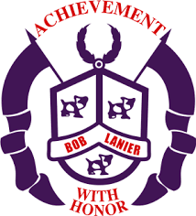**Bob Lanier Middle School**

**Shared Decision-Making Committee**

**October 29, 2020**

**MINUTES**

* **SIP Review The School Improvement Plan was reviewd by the members of the committee.**
* **School Safety**
* Physical
* **Coronavirus Protocols/Updates**
* **Nurse as primary communication Nurse Hechler gave an update on the evolving COVID-19 protocols. Reminded parents to contact her if they suspect an infection.**
* **Protocols continue to adapt**
* Emotional
* Rethink Ed through PUPS, HISD Resource Mr. Cooper explained how the PUPS class and SES are related.
* Sandy Hook
* PLC #1: What do we want our children to know and be able to do?
* **Team collaboration Mr. Cooper gave an overview of grade level planning and department meetings and how that collaboration was essential to provide equity to all students.**
  + **Virtual School/F2F**
  + **PLC**
* PLC #2: How will we know if our children have learned what we want them to learn?
* **CFU/Daily/Weekly Assessments**
* Common Formative Assessments
* Renaissance 360
* Data Driven Instruction for intervention and stretch
* PLC #3: How will we respond when, despite our best efforts, we discover that some of our children have not learned what we want them to learn?
* Tier 1 (regular classroom instruction)
* Tier 2 (teacher led in class, small flexible groups; one-on-one)
* Tier 3 pulled out by interventions specialist(s), tutorials
* ABC – Academic Boot Camp
  + Dr. Colburn
* PLC#4: How will we respond when we discover that some of our children already know what we want them to learn and be able to do?
* **New Business Proposed**

**Meeting Adjourned**